Work report 10 august 2021

The link for test dataset for yolo v4 is:

<https://drive.google.com/drive/folders/1idJmzlraw4ZRYj-1uWhCpubPjCwX-IA3?usp=sharing>

Then I have tested this data on the model at 3700 epochs

1. mAP on training data

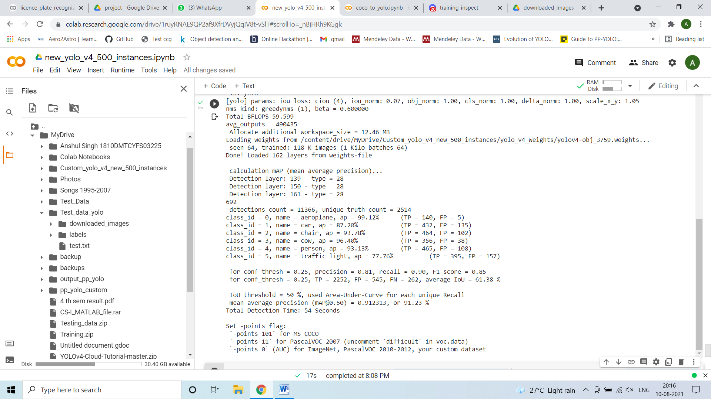

1. mAP on test dataset

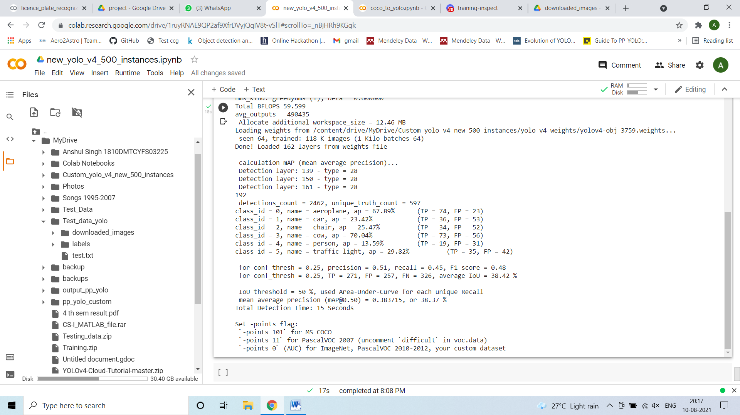

Then I have tried some images of person for detection but the detection was not good for that.

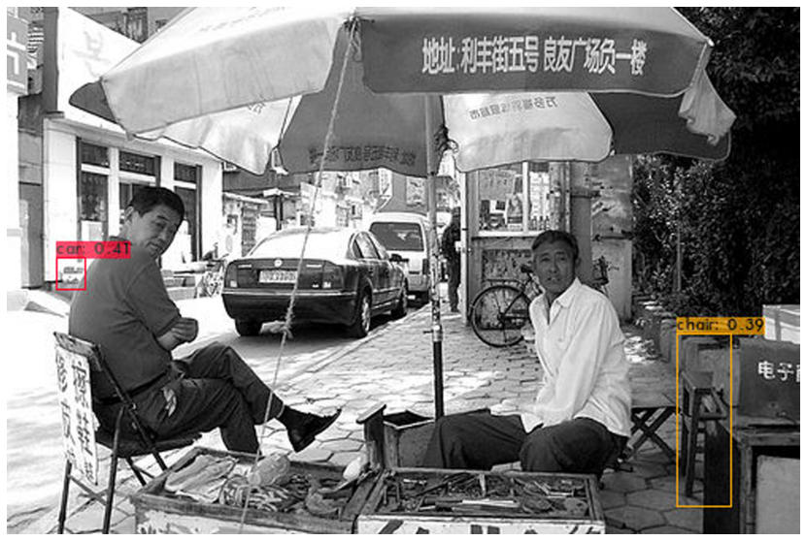

For video

I have check before and submitted report on 25 july.

Notebook link –

<https://colab.research.google.com/drive/1ruyRNAE9QP2af9XfrDVyjQqIV8t-vSlT?usp=sharing>